**The following code belongs to the database, it is highlighted below in the screenshot. Code for the tables “Options” and “Underlying” are afterwards in this document:**

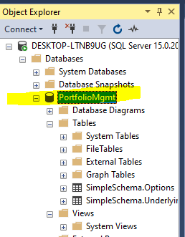

USE [master]

GO

/****** Object: Database [PortfolioMgmt] Script Date: 3/15/2020 5:46:38 PM ******/

CREATE DATABASE [PortfolioMgmt]

CONTAINMENT = NONE

ON PRIMARY

( NAME = N'PortfolioMgmt', FILENAME = N'C:\Program Files\Microsoft SQL Server\MSSQL15.MSSQLSERVER\MSSQL\DATA\PortfolioMgmt.mdf' , SIZE = 8192KB , MAXSIZE = UNLIMITED, FILEGROWTH = 65536KB )

LOG ON

( NAME = N'PortfolioMgmt_log', FILENAME = N'C:\Program Files\Microsoft SQL Server\MSSQL15.MSSQLSERVER\MSSQL\DATA\PortfolioMgmt_log.ldf' , SIZE = 8192KB , MAXSIZE = 2048GB , FILEGROWTH = 65536KB )

WITH CATALOG_COLLATION = DATABASE_DEFAULT

GO

IF (1 = FULLTEXTSERVICEPROPERTY('IsFullTextInstalled'))

begin

EXEC [PortfolioMgmt].[dbo].[sp_fulltext_database] @action = 'enable'

end

GO

ALTER DATABASE [PortfolioMgmt] SET ANSI_NULL_DEFAULT OFF

GO

ALTER DATABASE [PortfolioMgmt] SET ANSI_NULLS OFF

GO

ALTER DATABASE [PortfolioMgmt] SET ANSI_PADDING OFF

GO

ALTER DATABASE [PortfolioMgmt] SET ANSI_WARNINGS OFF

GO

ALTER DATABASE [PortfolioMgmt] SET ARITHABORT OFF

GO

ALTER DATABASE [PortfolioMgmt] SET AUTO_CLOSE OFF

GO

ALTER DATABASE [PortfolioMgmt] SET AUTO_SHRINK OFF

GO

ALTER DATABASE [PortfolioMgmt] SET AUTO_UPDATE_STATISTICS ON

GO

ALTER DATABASE [PortfolioMgmt] SET CURSOR_CLOSE_ON_COMMIT OFF

GO

ALTER DATABASE [PortfolioMgmt] SET CURSOR_DEFAULT GLOBAL

GO

ALTER DATABASE [PortfolioMgmt] SET CONCAT_NULL_YIELDS_NULL OFF

GO

ALTER DATABASE [PortfolioMgmt] SET NUMERIC_ROUNDABORT OFF

GO

ALTER DATABASE [PortfolioMgmt] SET QUOTED_IDENTIFIER OFF

GO

ALTER DATABASE [PortfolioMgmt] SET RECURSIVE_TRIGGERS OFF

GO

ALTER DATABASE [PortfolioMgmt] SET DISABLE_BROKER

GO

ALTER DATABASE [PortfolioMgmt] SET AUTO_UPDATE_STATISTICS_ASYNC OFF

GO

ALTER DATABASE [PortfolioMgmt] SET DATE_CORRELATION_OPTIMIZATION OFF

GO

ALTER DATABASE [PortfolioMgmt] SET TRUSTWORTHY OFF

GO

ALTER DATABASE [PortfolioMgmt] SET ALLOW_SNAPSHOT_ISOLATION OFF

GO

ALTER DATABASE [PortfolioMgmt] SET PARAMETERIZATION SIMPLE

GO

ALTER DATABASE [PortfolioMgmt] SET READ_COMMITTED_SNAPSHOT OFF

GO

ALTER DATABASE [PortfolioMgmt] SET HONOR_BROKER_PRIORITY OFF

GO

ALTER DATABASE [PortfolioMgmt] SET RECOVERY FULL

GO

ALTER DATABASE [PortfolioMgmt] SET MULTI_USER

GO

ALTER DATABASE [PortfolioMgmt] SET PAGE_VERIFY CHECKSUM

GO

ALTER DATABASE [PortfolioMgmt] SET DB_CHAINING OFF

GO

ALTER DATABASE [PortfolioMgmt] SET FILESTREAM( NON_TRANSACTED_ACCESS = OFF )

GO

ALTER DATABASE [PortfolioMgmt] SET TARGET_RECOVERY_TIME = 60 SECONDS

GO

ALTER DATABASE [PortfolioMgmt] SET DELAYED_DURABILITY = DISABLED

GO

ALTER DATABASE [PortfolioMgmt] SET QUERY_STORE = OFF

GO

ALTER DATABASE [PortfolioMgmt] SET READ_WRITE

GO

**================ END of database code ===========================**

**Code for Options table is below:**

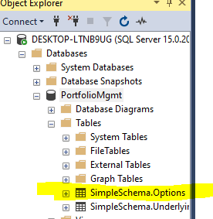

USE [PortfolioMgmt]

GO

/****** Object: Table [SimpleSchema].[Options] Script Date: 3/15/2020 5:47:28 PM ******/

SET ANSI_NULLS ON

GO

SET QUOTED_IDENTIFIER ON

GO

CREATE TABLE [SimpleSchema].[Options](

[ID_Key] [int] IDENTITY(1,1) NOT NULL,

[OptionStyle] [char](10) NULL,

[PutCall] [nchar](10) NULL,

[SpotPrice] [nchar](10) NULL,

[Strike] [nchar](10) NULL,

[Tenor] [int] NULL,

[Rate] [float] NULL,

[UnderlyingType] [nchar](10) NULL,

[UnderlyingID] [int] NULL

) ON [PRIMARY]

GO

**Underlying table code below:**

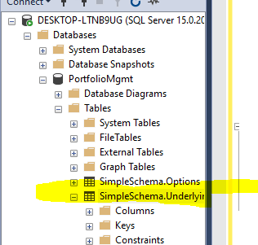

USE [PortfolioMgmt]

GO

/****** Object: Table [SimpleSchema].[Underlyings] Script Date: 3/15/2020 6:04:36 PM ******/

SET ANSI_NULLS ON

GO

SET QUOTED_IDENTIFIER ON

GO

CREATE TABLE [SimpleSchema].[Underlyings](

[ID_Key] [nchar](10) NOT NULL,

[AssetType] [char](10) NULL,

[SpotPrice] [float] NULL,

[MaturityDate] [date] NULL,

[Yield] [float] NULL

) ON [PRIMARY]

GO